Emma Castelnuovo
by Daniela Valenti
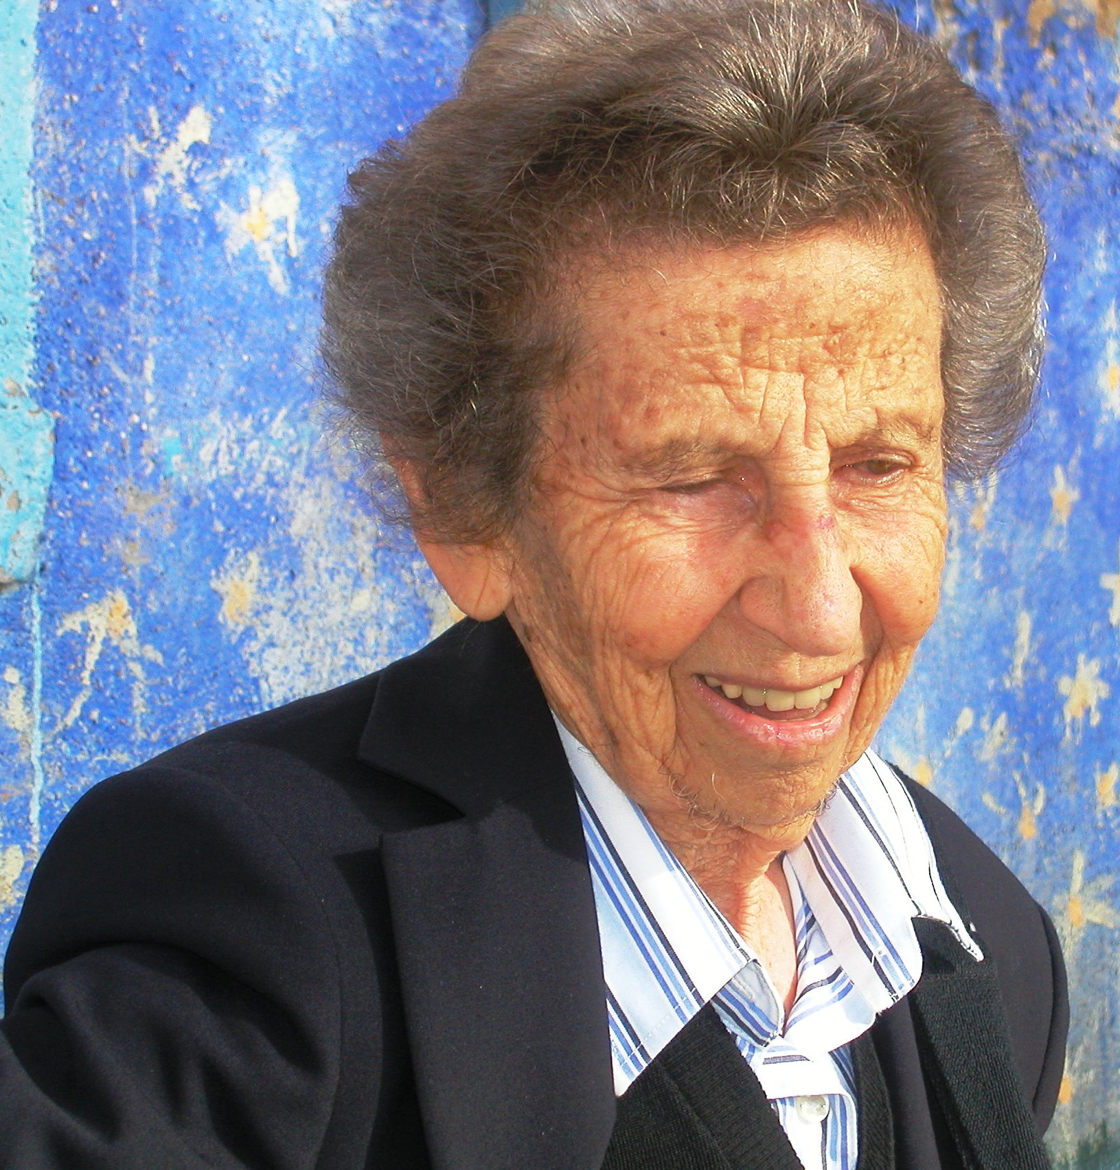

If you meet Emma Castelnuovo, you’ll forget she was born in 1913: she still preserves an acute awareness of changing fashions and an active interest in the teaching of mathematics, as you can see in the following links.
Lectio magistralis in Mathematics Festival, Rome 2007
Book ‘L’officina matematica’, published in 2008
Award ‘Grande Ufficiale della Repubblica Italiana’, conferred on her, Rome 2009
Come imparare la geometria? Video on Treccani website 2009
Quali materiali possono usare gli studenti in geometria? Video on Treccani website 2009
Che cosa suggeriscono le esperienze internazionali degli ultimi 50 anni? Interview on Treccani website 2009

Such a long and successful life would fill a book, so here you can find only a small part of her activities and, in particular, those related to CIEAEM.

Her adventure as a teacher – researcher in the education of mathematics began in 1946 with the paper ‘Il metodo intuitivo per insegnare la Geometria nel Primo Ciclo della Scuola Secondaria’, where you can find her early ideas, better developed in the revolutionary textbook ‘Geometria Intuitiva’ (1949).
It was this textbook that gave her the occasion to meet CIEAEM, as she herself tells us:
‘In 1951 Gattegno, who I had never met before, contacted me: he had just looked through my geometry textbook for Junior high school and he found that we shared some important aims; he told me about CIEAEM and proposed that I became a commission member. I was very interested, but it was not until 1954 that I had the possibility to attend a CIEAEM’s meeting.
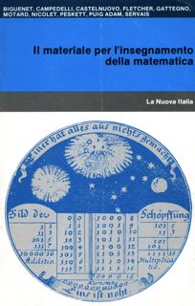
From the first meeting I was impressed by its friendly, welcoming atmosphere: university professors, secondary school teachers, mathematicians and researchers in pedagogy, all treated each other as equals and worked together with a contagious enthusiasm. …

In 1957, the theme of 11th CIEAEM meeting was ‘Teaching materials’ and a rich exhibition of materials was an important part of the meeting. On that occasion Emma presented a method to teach conic sections at junior high school by means of DIY materials: students of the Italian school in Madrid were involved in learning this new subject with an innovative method.
Following this conference, in 1958, CIEAEM promoted the publication of a book that collected articles from leading experts in mathematics education: ‘Le materiel pour l’enseignement des mathématiques’. In this book you can find Emma Castelnuovo’s paper: ‘l'objet et l'action dans l'enseignement de la géométrie intuitive’. The book was translated into many languages, among which Italian.
After that year, Emma was increasingly involved in the work of CIEAEM, which attracted teachers from all over the world in its very animated conferences: especially the young people received a strong impulse to experiment with new subjects and new methods.
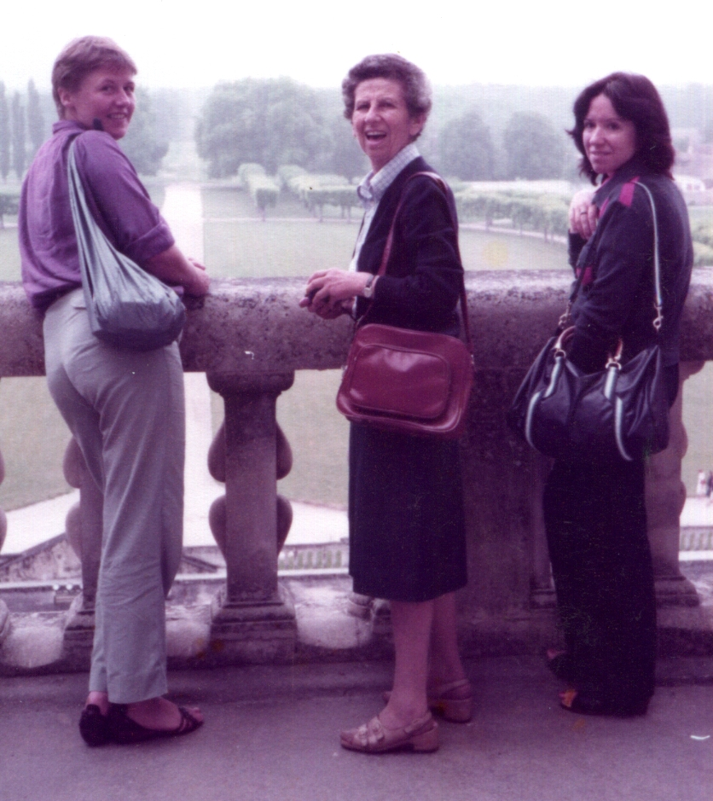
Rijkie Dekker, Emma Castelnuovo, Daniela Valenti,
CIEAEM’s meeting 1983
Ideas and methods discussed in the annual meetings of CIEAEM have had a considerable influence in the teaching of mathematics through Emma Castelnuovo, mainly through the following channels.
- Her book ‘Didattica della matematica’ (1963), translated into several languages, among which Spanish.
- Her worldwide courses for teachers’ training (after one of these courses, in 1991, La Sociedad Madrileña de Profesores de Matemáticas (SMPM) ‘Emma Castelnuovo’ was founded).
- Her textbooks still widespread in Italian junior high schools.
- Materials on dynamic geometry for overhead projector (1971), interesting ancestors of dynamic geometry software.
- Her participation in Committees that formulated the 1963 and 1979 reforms of the Italian junior high school.
- The exhibitions, organized in Rome every three years when she was teaching in a junior high school in Rome, where her students ‘explained maths to visitors’.
- Similar, unforgettable exhibitions of her African students at the end of her teaching experience, upon a Unesco mandate, in Niamey in 1977 and 1978.
- The exhibition of her Italian students, during the International Conference in 1979, on the occasion of her retirement as teacher in a junior high school in Rome.
She was vicepresident of the CIEAEM from 1974 to 1978 and became president in 1979 until 1980.
During the CIEAEM’s meeting in Mexico (in 1980), she gave a successful lecture titled ‘The history of this Commission’. As the proceedings of this meeting were not published, you can only find the French version of the lecture in the proceedings of the CIEAM’s meeting in 1981; but I have found the original typescript of this lecture and I have scanned it for your reference.
In the last paragraphs of this scanned document you can find: ‘… we can use mathematics as a means of collaboration, by making the students aware of the importance and utility of this science, even in a social perspective. Now – and this is the opinion of several among us – we can realize this direction only by stimulating our students with real problems. …’

Afterwards, she continued to research and work in order to construct and spread ‘mathematics in the real world’, nowadays more and more popular the world over.

